# 

Final – Approved at Academic Board, 10th November 2021

Vision 2030

Graduate Attributes Framework

Contents

1

Version Control 2

Introduction 2

Vision 2030 Commitments and Graduate Attributes 3

Inclusivity 4

Well-being 4

Sustainability 5

Digital 5

Community 5

Global 5

Knowledge, Attitudes, Skills and Habits 6

Mapping of Graduate Attributes Against Programme Level Outcomes 6

Example – BA (Hons) Business Management 6

Micro-Credential Awards 8

Timeline 8

## Version Control

Version 1 – VCAG, July 2021- key change agreed, timeline to delay whole university implementation until 2022/23

Version 2 – Circulated to SSSC

Version 3 – October USEC – agreed to add global citizenship

Final Version – Approved by Academic Board November 2021 with revised wording for global element

## Introduction

This paper outlines a proposed set of University of Wolverhampton graduate attributes and a model for their embedding into curricula.

Graduate attributes here are defined as:

*An aspirational list of knowledge, skills and values that an institution puts forward as a statement of intent so that:*

*… all graduates, at the end of their studies, irrespective of background, interests, and degree taken, will possess and be able to live out in the wider world these knowledge, skills and values through their work, and also through their lives.*

(Scott, <https://www.heacademy.ac.uk/download/idea-graduate-attribute> )

University of Wolverhampton graduates will:

* Be reflexive practitioners with a commitment to inclusivity, equity and diversity [Inclusivity]
* Be aware of their own wellbeing and that of others [Well-being]
* Demonstrate individual responsibility for sustainability and understand the importance of sustainability in their discipline area [Sustainability]
* Be confident and critical users of digital technologies [Digital]
* Make positive contributions to the economic, social and cultural life of their communities [Community]
* Apply their learning through a global lens in the places in which they live and work [Global]

These are drawn directly from Vison 2030. By embedding them into curricula (via programme outcomes) and co-curricula (via micro-credentials) we will ensure that the ambitions of Vision 2030 are embedded into our programmes and our students’ personal and professional development. This builds on the work carried out in 2020 on an Employability Framework and also the institutional project on sustainable development undertaken in 2019.

## Vision 2030 Commitments and Graduate Attributes

The following commitments in Vision 2030 are directly relevant to the development of a set of graduate attributes:

* Provide an individual programme of personal and professional development for each student
* Embed academically led and discipline specific approaches to well-being, sustainability, digital and community engagement within each programme.
* Match our students’ ambition to the needs of the local economy

Vision 2030 commits us to embedding a scaffolded approach to employability in all undergraduate programmes and to ensuring that we have a distinct masters level employability offering for postgraduate students. All of our students will graduate with the knowledge, attitudes and skills that equip them as global citizens to make a significant contribution to their communities, in our region and beyond. These will be articulated through a common set of graduate attributes that will be translated into programme learning outcomes for inclusivity, well-being, sustainability, digital skills and community engagement. These will that will combine with module level learning outcomes to evidence achievement against an institutional set of micro-credentials. Students will be able to map their own learning journey and evidence their own competencies in ways that enhance their employability.

The starting point for this is this set of graduate attributes aligned to the Higher Education Academy framework for embedding employability and our strategic priorities of inclusivity, well-being, sustainability and digital capabilities. This will translate to a programme-based, student-centred route-map to becoming a professional or expert for every student through the development of knowledge, attitudes, skills and habits specific to that discipline.

In instances where graduate attributes are not covered by programme learning outcomes, missing elements will be complemented by a range of co-curricula opportunities and activities leading to award of micro-credentials. Reversing this, these micro-credentials will also map to programmes and modules so that students can evidence where and how they have developed skills and competencies valued by employers. Additionally, students will be directed towards enrolling for micro-credentials that would help them to develop areas of weakness identified through their Personal Learning Plans. Finally, the development of a set of micro-credentials at introductory level upwards will mean that this in-university provision will support our Access and Lifelong learning strategy. They will form part of the pathways we offer in in partnership with a range of external stakeholders (schools, FE colleges, businesses, public sector and community organisations) to offer pathways into, through and out of HE.

### Inclusivity

Our inclusive framework underpins all our curriculum design and delivery. This consists of four overarching principles, with accompanying sub-principles, articulated through the following questions: Where am I in the curriculum? Are we removing obstacles to student success and progression? Are our student’s co-creators? How are we developing our inclusive lens?

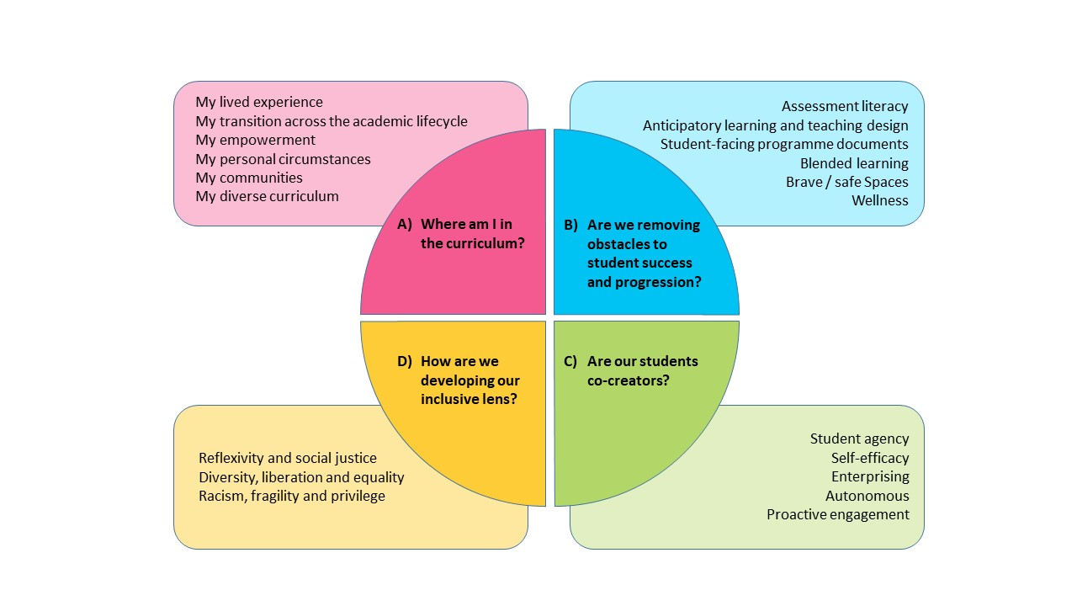

### Well-being

Well-being may be understood as a form of social capital that is embodied and is accumulated through an individual’s life journey. Thus, inclusivity and wellbeing are mutually reinforcing. Disabled students have to overcome barriers that do not challenge others and the testimonies of our students have exposed how many feel that they are othered by our structures and culture. An inclusive curriculum will nurture our students’ wellbeing by minimizing barriers and by helping to secure their sense of belonging as a member of the University community. We need to go further, however, and design in wellbeing so as to enable all of our students to achieve to their full potential.

### Sustainability

During 2019 there were a number of discussions and open meetings concerning Sustainable Development. These indicated a significant interest across the University in taking this initiative forward. There were many successful programmes and initiatives across the University already under way to move towards a more sustainable future. Nevertheless, a need was identified for a consistent and clear strategy to ensure engagement and to position the University as an innovator and leader in the debate. Additionally, the project recommended better promotion and communication of our activity and commitment. These recommendations are captured in our Vision 2030 ambition to be *nationally recognised for our holistic approach to sustainability*.

Three areas were identified as initial themes for moving forward the University’s approach to sustainability: Campus, Curriculum and Community. All of these connect to our proposed graduate attributes framework. Specifically, the project recommended a review of our curriculum to promote understanding and to embed environmental principles into our curriculum to ensure our students have a greater understanding of their own role and that of sustainability in their chosen career.

### Digital

Students will need to develop the digital skills required both to mediate their learning and to make them effective practitioners and researchers in their discipline.

### Community

Alongside Inclusive Student Success, the second pillar of our Vision 2030 is our commitment to place. We believe that universities are about transforming society by ensuring the needs of their Place and people are at the heart of what they do. We aim to support the economic, social, and cultural and inclusive growth of our region through the provision of skills based and employer led higher education. We encourage our students to give back to their communities, supporting their volunteering and developing an ethos of citizenship both through curricula and co-curricula activities.

### Global

As we look forward to 2030 we recognise that our impact as a University is growing both regionally, nationally and internationally and it is through this lens this Global Opportunities sub-strategy has been developed to capture our future ambitions to grow in size as we continue to remove barriers, grow our global reputation and grow our academic offerings through co-creation that focuses on producing Global citizens.

## Knowledge, Attitudes, Skills and Habits

The knowledge, attitudes, skills and habits which underpin the six graduate attributes are drawn from the Inclusive Curriculum Framework.

|  |  |
| --- | --- |
| Attribute (what our graduates do/are) | Knowledge, Attitudes, Skills and Habits (How) |
| Inclusivity: Reflexive practitioners with a commitment to inclusivity, equity and diversity  Well-being: Aware of their own wellbeing and that of others  Sustainability: Demonstrate individual responsibility for sustainability and understand the importance of sustainability  Digital: Confident and critical users of digital technologies  Community: Make positive contributions to the economic, social and cultural life of their communities  Global: Apply their learning through a global lens in the places in which they live and work | Empowered  Community- minded  Critical  Academically skilled  Adaptable  Resilient  Confident  Enterprising  Autonomous  Proactive  Reflexive  Enquiring  Challenging  Kind |

## Mapping of Graduate Attributes Against Programme Level Outcomes

These will then be translated into programme learning outcomes appropriate to the level of award and subject area. Where the University of Wolverhampton graduate attributes cannot be wholly met through the programme of study, students will be offered the opportunity to take co-curricula micro-credentials. Having a set of programme level outcomes based on the graduate attribute framework does not preclude programmes from having additional learning outcomes. Knowledge learning outcomes, must, by definition, be specific to the discipline and there will be behaviours, skills and attributes that are distinctive features of graduate level capabilities in any area. Similarly, programme level outcomes may cover more than one graduate attribute or several programme learning outcomes may feed into a graduate attribute.

### Example – BA (Hons) Business Management

|  |  |  |
| --- | --- | --- |
| Graduate Attribute | Programme Learning Outcomes | Modules |
| Inclusivity | Evaluate and demonstrate an informed understanding of ethical responsibilities contributing to their professional values and their role in organisations and society in the 21st century. | -every module mapped to inclusivity principles |
| Well-being |  | 5MG001 – The Professional Manager and Leadership,  4BU016 – The sustainable Business |
| Sustainability | Examine contemporary and strategic issues through the application of relevant analytical concepts, models and theories. | 4BU016 The Sustainable Business  5BU017 Operations and Project Planning  5FC004 Managing Finance and Accounts  6BE005 – The Strategic Business |
| Digital | Develop and apply research, writing, numerical, digital and personal skills within a business context. | 4BU017 The Digital Business  iDEA Digital awards embedded in modules throughout the programme of study |
| Community | Evaluate and demonstrate an informed understanding of ethical responsibilities contributing to their professional values and their roles in organisations and society in the 21st Century. | 4BU015 The Responsible Business  4BU016 The Sustainable Business |

## Micro-Credential Awards

Micro-credential awards will enable students to evidence their achievement both through their programme of study and through co-curricula activity against core competencies valued by employers. For example, a level 6 micro-credential in community engagement could be awarded on the basis of a relevant dissertation or on the completion of a set number of hours of volunteering and a reflective statement. These will be recorded through Portfolium and on the transcript. They will replace the existing Wolverhampton Enterprise and Employability Award.

## Timeline

July 2021 – Graduate Attributes Framework taken to VCAG for discussion

November 2021 – Agree Graduate Attributes Framework (Academic Board)

Academic Year 2021/22 – Use Graduate Attributes framework in revalidations

Academic Year 2022/23 – Design and run initial sample of micro-credentials

Academic Year 2022/23 onwards – All programmes mapped to Graduate Attributes Framework