

Students and Education
SUB-STRATEGY
FINAL
2021-2030

Contents

Introduction & Context 4
Outcomes from Consultation 4
Vision 6
Our Diversity 7
Foundations 8
1. Inclusivity 8
2. Well-being 8
3. Student-Centred 8
4. Partnership 8
5. Practice-Based 9
6. Programme Led 9
7. Community 9
Commitments 10
Key Strategic Priorities 14
Inclusive Curriculum Framework 14
MyWolves 14
The Wolverhampton Curriculum 15
Wolverhampton Institute for Students and Education 16
Success Measures 16
Relationship with the other sub-strategies 18
Appendix – Working Document on Delivery of the Vision 20
Appendix - SMART Action Plan 2021-2024 48

Introduction & Context (short summary highlighting purpose of the strategy and current challenges and opportunities)
Our priority is the success of all those who wish to study with us. Building on the progress made in our previous Strategic Plan in improving outcomes and satisfaction levels for our students, our focus for the next decade is to ensure greater inclusivity and ensure equity of outcome. This commitment will ensure that we focus on who is participating and how they achieve. We are committed to removing barriers to ensure that all can participate and achieve their potential. We will develop our approach guided by social models of outcome, adapting the way we work to suit individual needs, adding value to their experience and ensuring they become successful ambassadors for the University of Wolverhampton.
We will offer safe, inclusive and accessible learning environments, both on campus and online that enable students to manage their learning to suit their circumstances and preferences. We are the University of Opportunity, and we will create flexible and personalised learning and progression routes into, through and beyond university in a manner which transforms the places we serve.
The engagement of students and empowering them to be co-creators of their educational experiences will be critical to our success and the culture we will build. We are committed to working in partnership with our Students’ Union to ensure that our students have a fulfilling experience during their time with us, have a strong sense of belonging, and are empowered to overcome any barriers they might face.
To transform the leadership and workforce of our Place through inclusive student success and world-class research, we will offer to all those who can benefit a higher education experience that equips them to make a significant contribution to their communities both as students and as graduates. We will set the bar high for our expectations of our students; supporting them in all aspects of their university experience but challenging them to do their best for themselves and their communities. Through our alumni networks and our partnerships with regional schools, colleges, businesses and community organisations our students will both benefit from and contribute to the part that the University will play in the post-pandemic recovery of our region.
For every student we will provide a programme-based, student-centred route-map to becoming a professional or expert in their chosen area. Our programmes will provide a practice-based education that develops knowledge, attitudes, skills and habits specific to that discipline. What will unify our offering will be the fore-grounding of inclusivity and well-being across our portfolio and the embedding of digital skills and sustainability principles.

Outcomes from Consultation
The consultation on the sub-strategy took place during April and May 2021, including:
- Meeting with School Representatives
- Q&A with students
- Q&A with staff
- Meetings with Faculty DAGs/Leadership teams
- Meeting with extended Professional Services Leadership Group
- Meeting with the Professoriate
- Meeting with COLT
- Email inbox managed by SPPO
There was consensus on the overall direction of the sub-strategy including the foundations, the strategic initiatives and the commitments. Themes that came out from the discussions and which have been addressed in the final iteration were:
Need for greater recognition of the diversity of the student population: significant proportion of mature students, growing numbers of international students, postgraduate as well as undergraduate | Descriptive statistics included to demonstrate diversity of student population. Text of sub-strategy reviewed and KPTs revised to include PGT.
Need to ensure alignment of the four sub-strategies, particularly ensuring that research led teaching is not side-lined by practice based education | We have worked together as a team to ensure that the four sub-faculties are aligned. Reviewing the Education and Students sub-strategy, I have tried to ensure that the connections are clearer, for example, research inspired learning and lifelong learning. I have also added a diagram that shows how the Students and Education sub-strategy draws on the other three sub-strategies.
Need to build on existing initiatives | These are referenced through the working document on the delivery of the strategy and will also form starting points and foundations for some of the strategic initiatives (for example, the Student Campus Project will underpin MyWolves).
Concern that initiatives are resource dependent, particularly MyWolves | This is an obvious concern, particularly in the current economic climate and these proposals will need to be fully costed and payback periods determined.
MyWolves needs to be more than just a systems solution for tracking student journey through university | This initiative has been broadened out to encompass community, journey and partnership.
Need for development and training for all staff not just those who teach, particularly with regard to respect agenda and cultural awareness. | This is acknowledged. The Inclusive Curriculum and CARE Framework need to be interconnected and this will be a theme of this year’s Inclusivity Conference.
Need for realism about pace with which we can move to proposed flexibility of assessment | Recognising the need for a stepped approach, we are proposing a two year enhanced assessment practice project.
Consideration of what Vision 2030 means for students at partner institutions | We will use the UK and international partner forums to share Vision 2030 with our partners
Some students did not like the use of the term BAME | The term BAME has been removed from the sub-strategy

Vision (where we want to be in 2030)
Our Vision for 2030 - Inclusive Student Success
To transform the leadership and workforce of our Place through inclusive student success and world-class research, we will offer to all those who can benefit a higher education experience that equips them to make a significant contribution to their communities both as students and as graduates
Aspect | Ambition | Commitment | Success
Access | We welcome all who want to benefit from higher education  We provide higher education at the place of need | Embed our role as the University of Opportunity, offering access and supporting success to all those who can benefit  Offer students choice about how and when they learn  Offer students choice about how and when they are assessed | Above sector benchmarks for participation of groups underrepresented in Higher Education at both UG and PGT
Access |  |  | Increase recruitment of mature students with a home postcode within 25 miles of the University from 2613 to 3000.
Access |  |  | Increase recruitment of students who are deaf or have a hearing impairment from 23 to 30.
Belonging | All our students and staff believe they belong  Our students and staff have flexible and supported access to services | Work in partnership based on excellence in teaching and support from staff and on responsibility for engagement in their learning from students  Recognise and reward excellence in inclusive teaching and student support  Provide an individual programme of personal and professional development for each student  Provide student-centred support that integrates the academic and non-academic to meet the needs of the individual  Support students to manage their own well-being during and after university | Remove all significant gaps in award and continuation at both UG & PGT
Belonging |  |  | Difference in non-continuation rates between IMD quintile 3,4,5 and quintile 1,2 students from 5.5% to 1.4%
Belonging |  |  | Difference in non-continuation rates between black and white full time students from 4.6% to 1.2%
Belonging |  |  | Difference in degree award (1st and 2:1) between white and black students from 26% to 6%
Belonging |  |  | Difference in degree attainment (1st and 2:1) between IMD quintile 5 and quintile 1 students from 15% to 7.5%
Belonging |  |  | Student satisfaction scores to be consistently above sector average for all groups of students
Belonging |  |  | + 1% above sector average in NSS, PTES and PRES with no significant gaps by ethnicity or IMD
Achievement | all our students and staff achieve their potential  we raise and enable the ambition of our place  our students and alumni transform our region and their communities | Match our students’ ambition to the needs of the local economy  Embed a scaffolded approach to employability in all undergraduate programmes and ensure that we have a distinct masters level employability offering for postgraduate students  Embed well-being, sustainability, digital and community engagement within each programme | Remove all significant gaps in highly skilled employability rates
Achievement |  |  | Difference in progression (highly skilled employment or further study) between IMD quintile 5 and quintile 1 students reduced from 10% to 5%
Achievement |  |  | Difference in progression (highly skilled employment or further study) between Black, Asian and White First Degree students reduced from 6% to 3%
FOUNDATIONS
Student-Centred Programme-Led Practice-Based Inclusivity Wellbeing Partnership Community
Our Values
- Behave respectfully and ethically • Be inclusive and fair • Listen and learn from others.
Act professionally, transparently, confidently, collaboratively and challengingly

Our Diversity

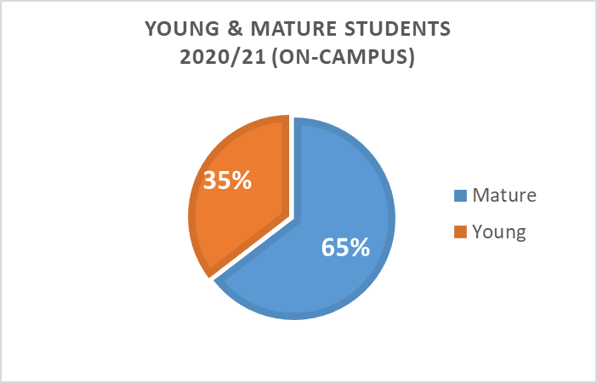 | 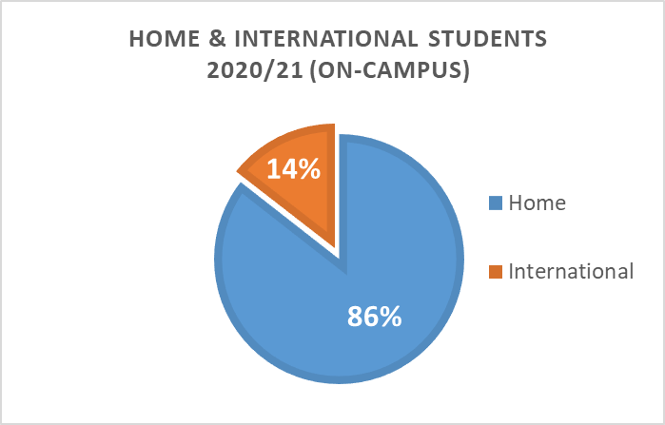
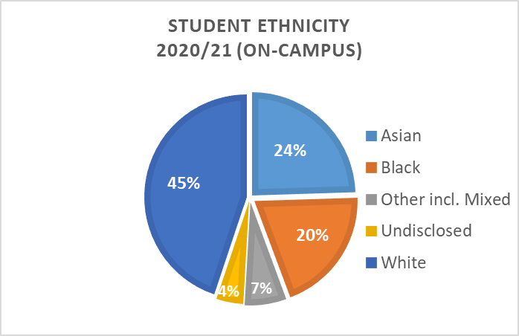 | 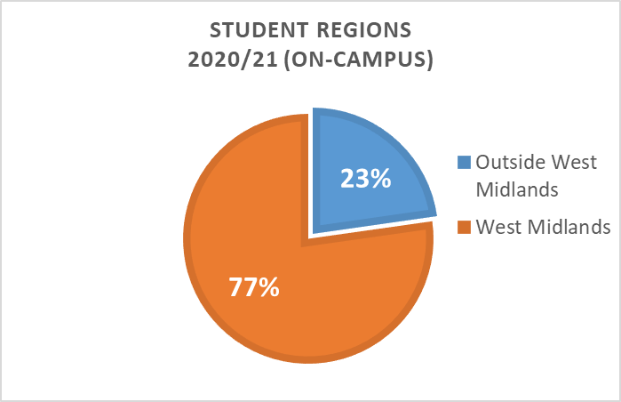
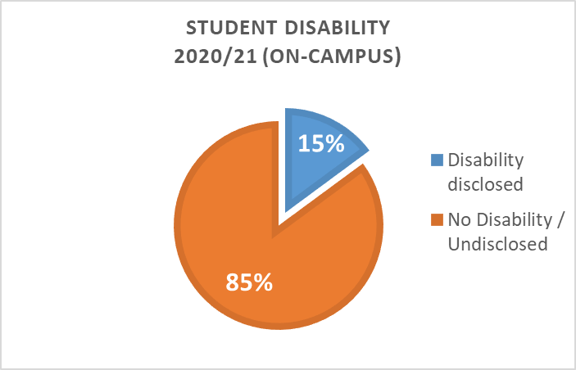 | 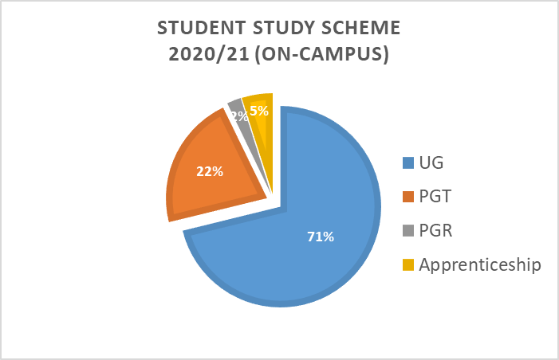
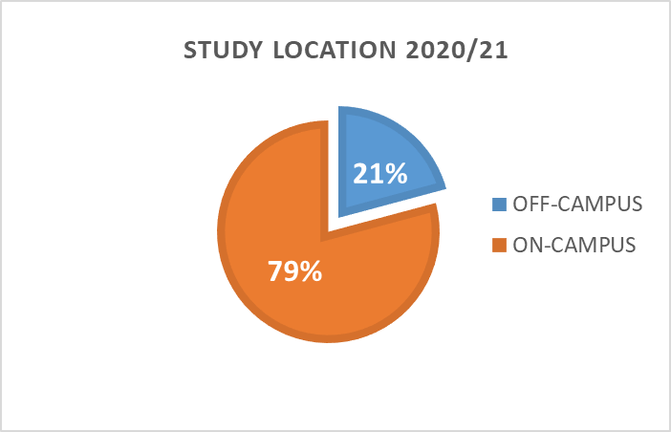 | 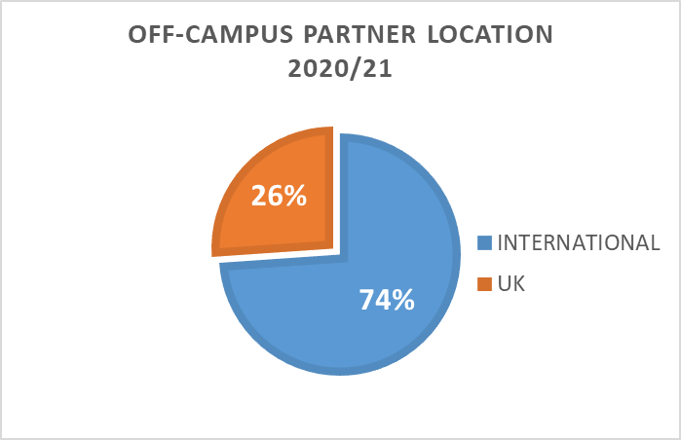

Foundations

Inclusivity
Inclusivity underpins Vision 2030. We attract a highly diverse student population who bring with them their identities and interests from their own communities (local, regional, national and international). Many are first in family to higher education and have to fit study into busy and complex lives, coming to university as mature students. The number of international students has increased significantly in the last two years and our ambition is to grow these numbers further. Our students’ sense of belonging may be fragile and easily damaged. We have a responsibility to adopt respectful behaviours, to demonstrate that we care and to build an inclusive culture in order that all of our students can succeed in meeting their full potential. The design and delivery of our courses must be informed by students’ lived experiences and interests, thereby nurturing their sense of belonging.

Well-being
Well-being may be understood as a form of social capital that is embodied and is accumulated through an individual’s life journey. Thus, inclusivity and wellbeing are mutually reinforcing. Disabled students have to overcome barriers that do not challenge others and the testimonies of our students have exposed how many feel that they are othered by our structures and culture. An inclusive curriculum will nurture our students’ wellbeing by minimizing barriers and by helping to secure their sense of belonging as a member of the University community. We need to go further, however, and design in wellbeing so as to enable all of our students to achieve to their full potential.

Student-Centred
The diversity of our student population and the complexity of their lives require us to take a student-centred approach. Learning and assessment needs to be delivered at a pace, in formats and through media that meet the needs of individual students. Both academic and pastoral student support need to be built around the specific needs of each student, recognising the differences in life histories and journeys into higher education.

Partnership
The Inclusive Curriculum Framework positions students and staff as co-creators of the educational journeys of our students. The student voice (the thoughts, views and opinions of our students) needs to be heard and listened to in order to shape the student experience at the University of Wolverhampton. We are committed to working in partnership with the Students’ Union to ensure that all students have a fulfilling experience during their time with us, have a strong sense of belonging, and are empowered to overcome any barriers they might face. Critically, all students and all staff must have agency and self-efficacy, be enterprising and autonomous and pro-actively engaged if we are to effect broad and deep cultural change.

Practice-Based
Practice Based Learning (PBL) has always been a key aspect of the University’s pedagogical approach. Through applying their learning in real-life or simulations students secure, reinforce and extend their understanding and develop their skills, attributes and confidence. Methods and applications will differ across disciplines but it is important to understand that PBL is not limited to those courses which prepare students for a specified profession. Moreover, since society’s grand challenges require inter-disciplinary solutions, practice based education will be richer where it draws together students from different subject areas.

Programme Led
Whole programme thinking, whereby the programme rather than the module is the primary unit of design, should ensure scaffolded learning and facilitate assessment that is joined up, varied and sufficient without being overly onerous to either students or staff. Looking at the student experience through the lens of the programme rather than the module facilitates a student centred approach, designing in progression to independent learning and transitions into and out of higher education. Linking to practice based learning and partnership, we need to build communities of practice around the domain of the discipline in which students, staff and alumni actively and collectively participate.

Community
The second pillar of our Vision 2030 is our commitment to place. We believe that universities are about transforming society by ensuring the needs of their Place and people are at the heart of what they do. We aim to support the economic, social, and cultural and inclusive growth of our region through the provision of skills based and employer led higher education. We encourage our students to give back to their communities, supporting their volunteering and developing an ethos of citizenship both through curricula and co-curricula activities.

Commitments (our pledges to ensure the vision can be realised)

Work in partnership based on excellence in teaching and support from staff and on responsibility for engagement in their learning from students
The University will be acknowledged by Students Unions nationally for its standing as an anti-racist organisation. We will be known nationally for nurturing our students’ sense of agency by recognising them as active participants in their own learning, enabling them to take purposeful initiative which gives them choice and voice in what and how they learn. We will have a reputation nationally for partnering with our SU to keep our students at the centre of our organisation and making sure their views and opinions truly guide us, through our effective representation systems. We will be known nationally for keeping our students fully and proactively engaged in all aspects of their studies.
We will have eradicated all award gaps through inclusive learning, teaching and assessment practices and all our students will believe that they are co-creators with us and they belong. We will be a leading provider of structured social opportunities that facilitate broader student friendship and networks.

Offer students choice about how and when they learn;
Learning from experience during the pandemic, we will move to a blended learning model that is built around student choice. Each School will clearly set out how it will deliver student choice in the context of their discipline, meeting institutional standards for inclusivity and quality. Students will be able to organise their learning around their busy and complex lives, creating an individualised mix of online and on campus activities to suit them. They will set their own pace for the completion of their course, rather than working within a binary of full-time or part-time. Many of our courses will be delivered in blocks rather than the current dominant model of concurrent modules, enabling students to jump on and off as suits them. We will also offer a fully online portfolio that enables busy working professionals and those with significant family or other responsibilities to enhance their career prospects and to achieve their full potential. We will offer a distinctive range of micro-credentials that students can achieve through or alongside their modules or as standalone Continuing Professional Development.

Offer students choice about how and when they are assessed
The University will have an assessment policy that is coherent, relevant, detailed but easily understood by students and staff. Students will be offered a wide-range of assessment components (including in some instances the opportunity to formulate their own assessment plans) – effectively allowing them to build their own assessment pattern according to their strengths whilst ensuring they demonstrate all relevant learning outcomes. With the move to more block delivery, assessment will be more staggered through the semester. Other than where prohibited by the PSRB, we will move away from capped resits to a system where students are given a set number of opportunities for attempts for which their best mark at the end of the attempts stands. We will continue with a trust basis for mitigation and develop data based approaches to automatically offer extensions or additional attempts rather than students having to request them.

Provide an individual programme of personal and professional development for each student
Each student will have personalised personal and professional development pathway that they will map out with support from their personal tutor. This will signpost students to personal and professional development activities which maximise their learning potential, health and wellbeing and employability. Academic and professional skills will be embedded into the curricula with additional resources signposted to students on basis of individual need. Student engagement data will be readily available for personal tutors as part of a personal tutor dashboard facility. This will enable personal tutors to effectively support their personal students and recognise when to intervene to offer additional support.

Provide student-centred support that integrates the academic and non-academic to meet the needs of the individual
Students will be confident that the University is providing the support that they need to succeed at university and that they will be treated respectfully at all times. We will operate a single point of contact for all students providing appropriate, instant and accessible student support at the point of need. All staff in student-facing roles will have the cultural awareness and commitment to inclusivity needed to ensure that support is truly accessible to all of our diverse student population. They will have clear spans of accountability and agency to act within these, ensuring prompt resolution of issues. Whilst our support to students will embed a customer service culture, our ethos will be one of partnership. We will empower our students to make effective use of the support available to them in navigating their own journey through their studies. We will work in partnership with our students to constantly improve our provision and to enable them to develop peer support systems that complement this.

Embed a scaffolded approach to employability in all undergraduate programmes and ensure that we have a distinct masters level employability offering for postgraduate students
We will develop a set of graduate attributes aligned to the Higher Education Academy framework for embedding employability and our strategic priorities of inclusivity, well-being, sustainability and digital capabilities. This will translate to a programme-based, student-centred route-map to becoming a professional or expert for every student through the development of knowledge, attitudes, skills and habits specific to that discipline. There will be embedded discipline-led employability structures within each Faculty to drive improvement in employment outcomes, ensure engagement and an inclusive approach. Additionally we will target resources and support specific groups of students in order to reduce the gaps in progression to highly skilled employment. We will create communities of practice that bring together students and alumni through mentoring, internships and placement support. We will work with internal and external stakeholders to procure employability opportunities within and outside the University. We will develop a distinct Postgraduate employability offer combining programme based elements with a core Masters level set of attributes.

Recognise and reward excellence in teaching at programme level that is research based and practice led.
We will offer outstanding academic staff development based on a shared institutional understanding of teaching excellence which emphasises inclusivity. This will be recognised nationally not just through our success in achieving HEA senior and professional status but being able to evidence how this enhances the student experience. Our conceptualisation of what is excellent will be developed through listening to and responding to the student voice. We will drawing in staff from across the institution not only to share good practice but also to shape it. There will be an institutional pedagogical research project that will focus on delivering inclusive student success at the University to which all Professors and Associate Professors in Learning and Teaching will make a significant contribution. Staff will feel supported in and will be confident in using digital resources and pedagogical approaches that deliver student achievement. All staff who teach will have a personalised three year development programme as part of an institutional scheme jointly managed by HR and CoLT. Annual development reviews and appraisals will be based around a common set of objectives drawn from the institutional success measures.

Embed academically led and discipline specific approaches to well-being, sustainability, digital and community engagement within each programme.
All of our students will graduate with the knowledge, attitudes and skills that equip them as global citizens to make a significant contribution to their communities, in our region and beyond. These will be articulated through a common set of graduate attributes that will be translated into programme learning outcomes for inclusivity, well-being, sustainability, digital skills and community engagement. These will be complemented by a range of co-curricula opportunities and activities that will combine with module level learning outcomes to evidence achievement against an institutional set of micro-credentials. Students will be able to map their own learning journey and evidence their own competencies in ways that enhance their employability.

Match our students’ ambition to the needs of the local economy
As the University of Opportunity, we will be the University of choice for students and employers, supporting lifelong learning for our region from child to grandparent. Our Access and Lifelong strategy will build on our existing pre-entry access work which supports adults and learners from a range of background into the University. We will work in partnership with a range of external stakeholders (schools, FE colleges, businesses, public sector and community organisations) to offer pathways into, through and out of HE. We will work with our students and partners to establish entrepreneurial solutions to regional problems through student and graduate start ups. We will be nationally leading in our contribution to the sectors that will play a significant part in the rebuilding of our region post-pandemic: Digital, Health & Social Care, Construction and Education. Our student-centred approach and its step on, step off model and standalone level 4 and 5 offerings will respond to the needs of the local economy. Our students’ ambition will not be bounded by our region but our models of practice-based learning and community engagement will mean students make a remarkable contribution to their place, both before and after graduation.

Design interventions that enable our students to develop their capabilities to manage their own wellbeing during and after university
The University will have a well-being strategy developed in partnership with students which will encompass mental and physical health. This will be embedded into all programmes and throughout the student journey in our support for transition into and out of university, academic skills development and through our values and behaviours. Peer support and student-led activities will be an integral part of our approach to well-being. Student wellbeing services will be strongly linked to communities both within and outside the University and inclusive of our student population and protected characteristic profiles. All (academic and non-academic) will be clear on sign posting and immediate referrals (in and outside of the university). All departments and services across the University will be trained on 3 minutes to save a life. Wellbeing will be integrated into our personal tutoring model and students will be encouraged to own their own wellbeing as part of their personal and professional development. We will be able to evidence increases in well-being at an individual and institutional level. Campus spaces will be designed to encourage connectivity and belonging for all students.

Key Strategic Priorities (how we intend to deliver our commitment, linked to the Ambition Statements and Goals of Vision 2030). This section should contain the breakdown of how different elements, initiatives or teams can support the priorities

The Students and Education Sub-Strategy will be delivered through four strategic initiatives:

- Inclusive Curriculum Framework
- MyWOLVES
- Wolverhampton Curriculum
- Institute for Inclusive Student Success

Inclusive Curriculum Framework

A distinctive element of our approach will be our inclusive framework for curriculum design and delivery. This consists of four overarching principles, with accompanying sub-principles, articulated through the following questions: Where am I in the curriculum? Are we removing obstacles to student success and progression? Are our student’s co-creators? How are we developing our inclusive lens?
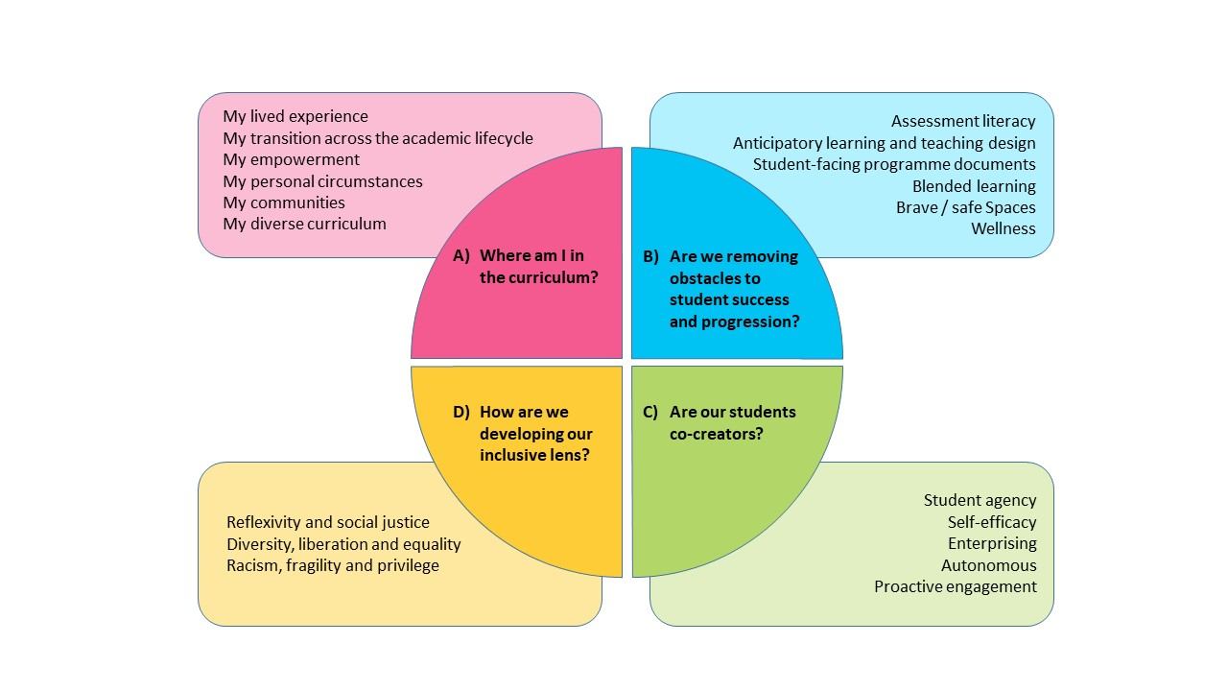

MyWolves

MyWolves will be our university model for partnership working for students and staff at both an individual and community level. It will set out the expectations of all members of the University through a Wolverhampton Commitment. This will be underpinned by the system that students use to plot, document and evidence their learning and development at the University of Wolverhampton and the dashboard in which all elements of their engagement and performance will be recorded (attendance, marks and feedback, personal tutor meeting forms). The system logic will reverse that of NHS medical records: the record will be a co-construction by the student and the University and it will be visible in its entirety to the student only.

The Wolverhampton Curriculum

The Wolverhampton curriculum will provide an institutional approach to ensuring all students develop the attributes we have committed to delivering for all students in Vision 2030. It will also provide the frameworks for our commitments to offer student choice in how and when they learn and are assessed.

Wolverhampton Institute for Students and Education

The Wolverhampton Institute for Students and Education (WISE), incorporating COLT, will develop, disseminate and evaluate excellence in learning, teaching and assessment. It will coordinate the work of Associate Professors of and Professors of Learning and Teaching to drive transformation in inclusive pedagogies. A group of institutional associate deans and academic leads will work in a matrix structure with Faculty DAGs and Directorates on the embedding of the sub-strategy foundations.

Success Measures (the long term visionary metrics to be achieved by 2030 – linked to our Goals)

Commitment | Goal | Lead Indicators | Success Measure
Embed our role as the University of Opportunity, offering access and supporting success to all those who can benefit | Embedded our role as the University of Opportunity, offering access and supporting success to all those who can benefit | Performance against outreach targets  Strategic partnerships with FE and employers  Learning centres reach  MAT outputs  Recruitment stats  Volume and range of employer partnership programmes | Above sector benchmarks for participation of groups underrepresented in Higher Education at both UG and PGT
 | Become recognised as a driving force for inclusivity |  | Increase recruitment of mature students with a home postcode within 25 miles of the University from 2613 to 3000.
 | Become recognised as a driving force for inclusivity |  | Increase recruitment of students who are deaf or have a hearing impairment from 23 to 30.
Work in partnership based on excellence in teaching and support from staff and on responsibility for engagement in their learning from students  Recognise and reward excellence in inclusive teaching and student support  Provide an individual programme of personal and professional development for each student  Provide student-centred support that integrates the academic and non-academic to meet the needs of the individual  Support students to manage their own well-being during and after university  Offer students choice about how and when they learn  Offer students choice about how and when they are assessed | Embedded co-creation at the heart of all we do | Student Journey dashboard outputs  Module mark profiles and increase in first attempt pass rates  Reduction in academic malpractice cases  Student feedback  Belonging survey  Closure of gaps at module level  Student feedback  Reach of engagement in student voice  Belonging survey  Alumni engagement measures  Student engagement in research and student awareness of research activity in their discipline  Student satisfaction scores  Students completing within their target period of study  Accessibility of online learning | Remove all significant gaps in continuation and award at both UG and PGT
 | Clearly defined subject and research identities to which our staff, students and alumni belong |  | Difference in non-continuation rates between IMD quintile 3,4,5 and quintile 1,2 students from 5.5% to 1.4%
 | Courses that are blended and accessed according to individual preference |  | Difference in non-continuation rates between black and white full time students from 4.6% to 1.2%
 | A personalised approach to learning centred around the student |  | Difference in degree award (1st and 2:1) between white and black students from 26% to 6%
 |  |  | Difference in degree attainment (1st and 2:1) between IMD quintile 5 and quintile 1 students from 15% to 7.5%
 |  |  | Student satisfaction scores to be consistently above sector average for all groups of students at both UG and PGT
 |  |  | + 1% above sector average in NSS, PTES and PRES with no significant gaps by ethnicity or IMD
Match our students’ ambition to the needs of the local economy  Embed a scaffolded approach to employability in all undergraduate programmes and ensure that we have a distinct masters level employability offering for postgraduate students  Embed well-being, sustainability, digital and community engagement within each programme | Ensured that all our students have the experience and employability skills to enable them to be global citizens | Engagement with Portfolium  Achievement of micro-credentials through embedding of enhanced academic and life skills model  Quality of practice-based activities/placements across portfolio  Mark profiles for practice based learning  Volume and range of employer partnership programmes | Remove all significant gaps in highly skilled employability rates
 | A curriculum, portfolio and delivery model that reflects the economic and societal needs of our area |  | Difference in progression (highly skilled employment or further study) between IMD quintile 5 and quintile 1 students reduced from 10% to 5%
 |  |  | Difference in progression (highly skilled employment or further study) between Black, Asian and White First Degree students reduced from 6% to 3%

Relationship with the other sub-strategies

Appendix – Working Document on Delivery of the Vision (planned activities to facilitate fulfilment of the key strategic objectives and operationalise at faculty and departmental level)

These plans of how to deliver the vision against each commitment were drafted by members of the Strategic Student Success Committee. Each table is followed by notes of the discussion in the SSSC away day. This work has formed the basis for the narrative against each of the commitments above. As part of the consultation on the sub-strategy, staff and students are invited to feedback on these plans ahead of them being formulated into action plans for 2021 – 2024.

Work in partnership based on excellence in teaching and support from staff and on responsibility for engagement in their learning from students

Where we are | Three Years | Ten Years | How this will be based on the sub-strategy Foundations | Required Investments, Initiatives, Culture Change
(1) Students Union has expressed frustration at the pace with which the University is moving on anti-racism agenda | Students Union will be confident in the University’s commitment to act as an anti-racist organisation. | The University will be acknowledged by Students Unions nationally for its standing as an anti-racist organisation | Partnership with students on implementation of the Inclusive Curriculum Framework  Staff development  Staff and student base reflective of regional communities | Access and Participation Plan  Race Equality Charter Delivery plan  Inclusive Framework  CARE Framework  Decolonising UoW  Culture change needs to underpin these strategic initiatives
(2) More work needed to build sense of partnership for success and increase students’ sense of agency over their own learning | Our programmes will foster student agency by recognising students as active participants in their own learning through our adoption of teaching and learning activities that are meaningful, relevant, initiated by them and driven by their own interests. | We will be known nationally for nurturing our students’ sense of agency by recognising them as active participants in their own learning, enabling them to take purposeful initiative which gives them choice and voice in what and how they learn. | Use of student voice  Application of Inclusive framework by all staff  Personalised/Student Centred approach to learning | Inclusive Framework  Training for student reps  Personal tutor dashboard/Engagement Insights
(3) Strong partnership working with the Students Union  and effective system of School reps | Building on the evidence of success of our school reps, we will continue to enhance our strategic cross-learning partnership with the Students Union | We will have a reputation nationally for partnering with our SU to keep our students at the centre of our organisation and making sure their views and opinions truly guide us, through our effective systems of student representation and student voice | Use of student Voice  ‘You said, we did’, to close feedback loop  Improved NSS satisfaction ratings for SU | Training for Student Reps  Inclusive Framework  Evaluation of student reps system and student voice  Caucus Leads
(4) NSS Scores for teaching above sector but variation at subject level | Our NSS scores for teaching will be consistently above sector average for all subjects | Our NSS scores for teaching will be consistently above sector average for all subjects and all groups of students.  (Are we able to distil ethnicity from the data for example?) | Personalised/Student Centred approach to learning  Use of student voice  Application of Inclusive Framework by all staff | NSS  Inclusive Framework  Staff development  Culture change
(5) Concerns from staff and school reps about student level of engagement | Our Wolverhampton commitment, our Engagement and attendance policy and the provision of a personalised approach to learning will ensure that all our students are fully engaged with all aspects of the learning experience. | We will be known nationally for keeping our students fully and proactively engaged in all aspects of their studies through our ‘Wolverhampton commitment’, our Engagement and Attendance policy and through the provision of a personalised and consistently excellent learning experience. | Application of Inclusive Framework by all staff  Introduction of ‘Engagement insights’ & Personal tutor dashboard  Implementation of the revised Blended Learning Principles | Digital Register  Personal tutor dashboard/Engagement Insights
(6) Award gaps indicate variations in effectiveness of teaching and assessment for different groups and in sense of belonging | We will have closed unexplained award gaps between students of different socioeconomic backgrounds and between ethnicities.  We will have fostered a sense of belonging for all students through inclusive learning, teaching and assessment practices. | We will have eradicated all award gaps through inclusive learning, teaching and assessment practices and all our students will believe that they are co-creators with us and they belong.  We will be a leading provider of structured social opportunities that facilitate broader student friendship and networks. | Application of Inclusive framework by all staff  Implementation of the revised Blended Learning Principles  Personalised/Student Centred approach to learning | Belonginess Survey  Race Equality Charter actions  Interventions/initiatives to support APP  Decolonising UoW  Student societies  Liberation Caucuses

Offer students choice about how and when they learn
Where we are | Three Years | Ten Years | How this will be based on the sub-strategy Foundations (not exhaustive) | Required Investments, Initiatives, Culture Change
System and processes and funding based on academic year rather than student centred  Blended learning experiment during 20/21 in response to pandemic  Need to understand what students what and need so can offer meaningful choice  Some programmes are offering block delivery  Developing online provision online carousel model | Students given the option to take at least 1-2 module per year 100% online  6-10 UG courses delivered in block mode, delivered through a standard timetable ie Mon – Wed 9am-1pm  PG – 24-27 Courses delivered in partnership with HEP  Expansion of micro credentials – CPD and to support alternative entry models  UG – Limited number of full 3 year courses carousel – 6  UG TOP up carousel courses –Skills White paper - | *Students given the option to take at ??% of the entire course content online  All digital content to be of An agreed standard across the Institution  Each school with an offer  Mature enough to move away from the partnership?  Standardised offer  Each school with an offer  Each school with an offer | Contribute toward offering student’s choice in both learning and also in assessment  We will also contribute towards providing an individual programme of personal and processional development for students.  Will contribute to the Global opportunities Sub Strategy around growing our population to 40,000 learners | Intro of Digital GTAs to focus on digital delivery, tutor students on-line and advise staff  Implement changes to academic calendar  Instructional designers and module standards established  Different academic role profiles  Pump priming for curriculum development via the business plan process- Job and finish  24/7 course offering, therefore changes to working practice and culture  Systems development and enhancement  *Further discussion about SLC implications required

Offer Students Choice about how and when they are assessed
Where we are | Three Years | Ten Years | How this will be based on the sub-strategy Foundations (not exhaustive) | Required Investments, Initiatives, Culture Change
Students are set one assessment brief per component | Students are offered a choice of at least 2 distinctly different (but equally weighted) briefs per a component to cater for different learning styles | Students are offered a wide-range of assessment components (each with specific weighting) to choose from – effectively allowing them to build their own assessment pattern according to their strengths  Students in some instances are able to formulate their own assessment plans, proposing the way in which they will meet learning outcomes | Inclusivity  Wellbeing  Student-centred learning | Validation and modification processes to be adjusted to allow and assure ‘student choice’ built into assessment patterns  System developments (both Canvas and SITS) to seamlessly support student choice.  Academic resource to establish and mark increased variety of assessment types
Students are set due dates in isolation resulting in significant assessment bunching | Assessment due dates are set with clear visibility of all deadlines within a given module diet.  Exception reporting identifies where a due date will result in assessment bunching | Concurrent module study is replaced with carousel models where assessment is staggered through the semester and does not overlap | Student-centred learning  Wellbeing  Programme based | System developments (both Canvas and SITS)
Reassessment records are not available until after a board ratifies the failed mark, with portals only generated 4 weeks in advance of submission | Students will have sight of, and the ability to submit, reassessment from the moment a failed mark is internally modified  All UG modules (not just SEM1) will be given a third attempt opportunity | Reassessment opportunities are made available every month, and the student simply submits to the next opportunity and continues to do so until all opportunities are exhausted | Student-centred learning  Wellbeing  Programme based | Implementation of changes to exam board process  System developments (both Canvas and SITS)  Academic resource to mark whilst also teaching
Extenuating circumstances and deadline extensions are not automatic but instead reliant on the submission of evidence. | Review extenuating circumstances policy and procedures, including the effectiveness of ‘Fit to Sit’ policy and with a view to permitting two uncapped attempts for all assessments (unless there is a PSRB restriction). | Extenuating circumstances and extensions are automatically offered to a student without them requesting – such offers would be generated from data (e.g. learner analytics) | Student-centred learning  Wellbeing  Programme based | System developments (both Canvas and SITS)  Student communication (implication of decisions)  Support the change through academic resourcing – particularly with regards to pressure on marking windows building
Assessment policy does not exist as a policy in its own right – fragments found in academic regulations and handbooks, but not in a central coherent document. Varying practices across the university | An assessment policy that is coherent, relevant, detailed but still understood. It will define (in a course specific way) all aspects of assessment. Need to define components versus elements, guidelines for the number of assessments, what reassessment is. | Actions processed by students or staff trigger warnings related to assessment policy and wider academic regulations. For example, requests for extensions or deferrals are assessed by an algorithm and the impact on the student’s study pattern, funding, completion date etc are shown immediately and before execution of the command. | Student-centred learning | System developments (both Canvas and SITS)
Under the existing regulations, students have their assessment capped at the qualifying mark where they have failed their first attempt (with exception of level 3 and 4 who are not capped where their first attempt attracts a mark greater than 19). | Students are given a set number of attempts for which their best mark at the end of the attempts stands e.g. first submit 22, second 55. 55 stands. |  | Student-centred learning  Wellbeing

Provide an individual programme of personal and professional development for each student
Where is the gap? | One Year | Three Years | How this will be based on the sub-strategy Foundations (not exhaustive) | Required Investments, Initiatives, Culture Change
Portfolium has been identified as a personalised system for students to evidence personal and professional development throughout their course.  It provides an opportunity for students to build their skills, presenting their learning journey and development to personal tutors and future employers.  Needs to offer choices so that it is tailored to the individual learning needs based on an individual skills analysis at points during the course, offering opportunities to develop skills further  It also provides a safe environment for students to engage in personal reflection and consider own health and wellbeing.  It provides an opportunity for personal tutors to review how their student is progressing and to offer additional support/sign-posting as needed, particularly in relation to health and wellbeing  Portfolium is not yet widely used across the university although it is available within Canvas  There is no identified framework within Portfolium currently to support this activity | A Portfolium pathway will be developed to support personalised personal and professional development for students through personal tutor support and coaching.  The Personal Tutor Pathway will signpost students to personal and professional development activities which maximise their learning potential, health and wellbeing and employability.  The basic personal tutor pathway will be identified as standard with the opportunity for add-ons depending upon the needs of the student – learning and/or employability needs | Portfolium will be fully embedded into the students’ learning journey  Portfolium will be used as standard to provide a personal and professional development pathway for each student as part of personal tutor support/coaching  Students' personal development potential will be maximised  Students' employability prosects will be maximised.  Students from all backgrounds will be supported to access health and wellbeing support available. | Programme based  Student centred  Partnership  Inclusivity | Inclusive Curriculum Framework  Student training  Staff training  Small working group of personal tutors and students to develop the standard Personal Tutor Pathway.  Additional working groups locally by subject area with employers, academics and students to identify development opportunities that would maximise the student’s employability prospects - particularly important in a post-Covid world.
All students are allocated a personal tutor in line with the new Personal Tutor Policy and revised role descriptor:  Levels 3 and 4 – academic coaches  Levels 5-8 lecturer  There is currently no electronic mechanism to ‘hand-over’ the personal tutor role from L4 to L5.  There is currently no electronic facility for personal tutors to access a personal tutor dashboard facility or for recording personal tutor interaction.  More investment in PT training, to include Academic Coaches, is necessary. | Portfolium will be adopted as the mechanism for transfer of personal tutor for students progressing through academic levels  Student engagement data will be readily available for personal tutors as part of a personal tutor dashboard facility. This will enable personal tutors to effectively support their personal students and recognise when to intervene to offer additional support | The Portfolium personal tutor pathway will be fully embedded into the personal tutor/student journey  A dashboard facility for personal tutors to view the progress of their personal tutees will be fully established and integrated into current electronic systems | Programme based  Student centred  Partnership  Inclusivity | Inclusive Curriculum Framework  Development of a personal tutor dashboard
There is a lack of coordination of all elements of academic student support across the university. | The personal student pathway will be used in Portfolium to signpost students to study skills advice relating to academic integrity | Reduced AM cases. | Programme based  Student centred  Partnership | Inclusive Curriculum Framework
There are some pilots ongoing which link well-being and personal and professional development | Evaluation data of the well-being pilots will be completed and disseminated | Interventions to improve student health and wellbeing will be fully embedded into the Personal Tutor Pathway in Portfolium | Programme based  Student centred  Partnership  Wellbeing  Inclusivity

Provide student-centred support that integrates the academic and non-academic to meet the needs of the individual
Where is the gap? | Where do we need to be in 3 years? | Where do we need to be in 10 years? | How this will be based on the sub-strategy Foundations (not exhaustive) | Required Investments, Initiatives, Culture Change
- Lots of support but not joined up; in particular, professional services and academic support; lack of staff ‘ownership’ of issues, students passed around  - Gap between perception and reality: staff think of themselves as ‘student focused’ but students don’t feel centre of attention; all systems and processes must put student at the centre  - Need systems, structure and culture change to facilitate this | Structures: One-stop shop for student support to prevent students from being passed around with resolution  Systems: more user-friendly systems for students and staff  Culture: ‘Students First’ – developing & embedding a customer service culture  Communication: clear student communication and set clear expectations supported by service level agreements  Support: offer support packages to students to meet physical needs and remove barriers to study | Structures: single point of contact for all students providing appropriate, instant and accessible student support at the point of need  Systems: Fully integrated IT systems and clear processes which map against the student journey  Culture: ‘Students First’ – customer service culture  Communication: two-way clear communications and clear expectation management  Support: include all support resources, i.e. technology, in fees so all students start with the same access to resources |  | Structures: Implement Student Campus project to facilitate all other activity  Systems: Review all IT platforms and systems and work towards a fully integrated system which offers a high spec front end system for students, combining e-vision and Canvas functionality, and an integrated back-end system, which offers accurate and accessible data for professional services and academic staff to better support individual students  Culture: identifying change agents  Communication: review student communications, including channels, frequency and accessibility  Support: Review the resources students need to study and what they have access to; review other Universities to see what support packages are offered to students

Embed a scaffolded approach to employability in all undergraduate programmes and ensure that we have a distinct masters level employability offering for postgraduate students
Where we are | Three Years | Ten Years | How this will be based on the sub-strategy Foundations (not exhaustive) | Required Investments, Initiatives, Culture Change
Significant Employment outcome disparities identified in APP and Government agenda moving towards linking “low value” courses with highly skilled employment outcomes.  Below sector outcomes for highly skilled employment and unemployment rates  Very significant differences in employment outcomes by subject in initial “start to success” metrics.  Lack of a consistent and distinct PG employability offer | Have an agreed University employability framework within which all faculties can develop a consistent approach building on University employability award and graduate attributes framework  Have clearly established and embedded discipline-led employability structures within each Faculty to drive improvement in employment outcomes, ensure engagement and an inclusive approach.  Develop a programme-based, student-centred route-map to becoming a professional or expert for every student through the development of knowledge, attitudes, skills and habits specific to that discipline.  Use portfolium within programmes to develop consistent approach to e-portfolio development  Use career readiness survey (ACR) to focus attention on skills gaps  Focussed alumni office support to support mentoring, internships and placement support  Consistent exploitation of procurement employability opportunities at programme/faculty level  Develop a distinct PG a employability offer combining programme based elements with central support. | In order to achieve the vision of the 2030 plan into highly skilled to transform the leadership and workforce of our Place , we will have improved our employment outcomes for all students and removed all significant gaps in highly skilled employment rates.  Scaffolded employability support will be in place at all levels of programmes to ensure that students employment outcomes are improved across all programmes | Programme led and student centred approach  Inclusive approach through embedding within programmes | Culture change to move to programme based focus on employability  Investment in mentoring and placement support  Non vocational PG programmes develop distinct employability offer  Move to personalised, student-centred approach to employability

Recognise and reward excellence in teaching at programme level that is research based and practice led

Where we are now | Three Year Vision | Ten Year Vision | Relation to Foundations | Required investments, strategic change initiatives and elements of culture change
- Learning and Teaching pathways for promotion in place  - Coordination of objectives for L&T Associate Profs/Profs required  - Some structural issues with distance between research professors and curriculum in some areas  - Some good examples of student research that could be built out from  - Strong practice based/experiential learning base to both PSRB and non-PSRB provision | Coordinated objectives for Learning & Teaching Associate Professors and Professors  SMRSA time focused on achievement of 2030 vision  Working paper and seminar series  External-facing webpages (CoLT) | Equivalence of learning and teaching professors and research professors in both status and number  Internationally recognised for our pedagogy across a range of disciplines | Objectives would be based on foundations of Student-Centred, ​Programme-Led, Practice-Based, Inclusivity, Partnership, Well-being, ​Community | Culture change – expectation that scholarship allowances are used for achievement of collective strategic priorities  Through recognition that workload allowances for L&T Assoc Profs/Profs L&T responsibilities and for SMRSA need to be used for collective achievement of strategic priorities  Finance for increments for fellowship scheme
Above benchmark for HEA fellowship and senior fellowship. More limited on Principal Fellowship  KUDOS applications are a wealth of good practice but are not well-used for organisational learning at present | Increase number and spread of PFHEAs  Bring PFHEAs into the KUDOS Scheme potentially through a syndicate scheme (West Midlands Combined Universities)  All Fellowship applications demonstrate alignment with the Inclusive Curriculum Framework  Fellowship scheme / Standing panel of experts / celebration  Sharing and dissemination of excellence in learning and teaching scholarship and professional practice |  | Community | Time for applicants and for mentors  Establishment of regional scheme
NSS and SU Awards indicate areas of high levels of student satisfaction with teaching  Institutional ethos of academics caring about students and vast numbers of academic colleagues going above and beyond to support students.  Some areas where teaching scores are below subject benchmark in NSS. | Zero tolerance of poor quality teaching  Institutional understanding of teaching excellence which emphasises inclusivity and based on consultation with students, based on SU awards and VC awards  Recognition of teaching excellence that delivers inclusive teaching success  Continuous student voice |  | Our definition of teaching excellence needs to be based on foundations of Student-Centred, ​Programme-Led, Practice-Based, Inclusivity, Partnership, Well-being, ​Community | Culture change  Common set of objectives for lecturer/senior lecturer/PL/Associate Prof/Prof that can be added to but not removed  Through CMI scheme, robust appraisal and review systems with standard objectives for teaching staff based on our APP targets  Open (and anonymous option) module feedback  Continue to build on existing student rep system  Review of student voice policy  Systems investment for information sharing (e.g., module outcomes by different student groups)
Wealth of staff development opportunities but fragmented and not taken up by all staff who could benefit  Staff are not always able to access the support they need especially for online teaching | Personalised staff 3 year development programme for each member of staff  An integrated approach across OD, CoLT and the Doctoral College.  Access to support in forms that staff request (at elbow, online, for credit)  Staff who feel supported in and are confident in using digital resources | Nationally recognised staff development programme | Partnership, Well-being | Investment in resources and academic time  Strategic initiative on micro-credentials for staff and students  CPD co-production with students

Embed academically led and discipline specific approaches to well-being, sustainability, digital and community engagement within each programme.

Where we are now | Three Year Vision | Ten Year Vision | Relation to Foundations | Required investments, strategic change initiatives and elements of culture change
- No institutional standards  - Need to understand current picture across all programmes  - Academic Lead for Mental Health and Wellbeing in post since September  - No equivalent lead for either digital or sustainability  - Some excellent examples of community engagement but lots of opportunities that can be taken up  - Limited opportunities for students to work across disciplines on grand challenges  - During pandemic the Students Union has strengthened partnerships working with community groups  - Digital poverty and lack of digital skills limit access to learning opportunities for significant number of students | Graduate level attributes for well-being, sustainability, digital, inclusivity and community engagement articulated and widely understood by staff and students  Graduate level attributes translated into programme level learning outcomes for all taught provision and programme level outcomes  Programme level outcomes mapped to module learning outcomes effectively ensuring all students demonstrate they meet threshold standards  Series of micro-credentials developed to badge students’ learning in sustainability, wellbeing, digital and community, mapped from their programme of study.  All students have access to digital resources, hardware and connectivity that they need for their studies. | Micro-credentials offer students opportunity for additionality, stretch and study outside of their own discipline  Micro-credentials achieved by students, staff and members of community  University of Wolverhampton students are recognised by employers for their effectiveness, experience and expertise in sustainability, digital, well-being, inclusivity and community engagement | Student-Centred, ​Programme-Led, Practice-Based, Inclusivity, Partnership, Well-being, ​Community | University wide-commitment to embedding these themes in all programmes  Development of academic staff so that they are confident to deliver themes within their programmes  Time for institutional leadership for each theme and connectivity through to programme level  Development of micro-credentials schema  Systems development for programme and module learning outcomes mapping to micro-credentials

Match our students’ ambition to the needs of the local economy
Where we are | Three Years | Ten Years | How this will be based on the sub-strategy Foundations (not exhaustive) | Required Investments, Initiatives, Culture Change
Below sector outcomes for highly skilled employment indicate a mismatch between supply and demand | Above sector –in leading areas such as Digital, Health, Architecture and Built Environment  On sector benchmark– all areas | Above benchmark all sectors and seen as national lead in specialised areas such as Health | Work in partnership with the communities we serve  Scaffolded curriculum design  Practice based learning | KEF  Horizon scanning  Business partnerships linked curriculum design
Need to develop employability offering for our growing numbers of international students | Established suite of courses offering placement opportunities for international students in the UK incl global employer brands | Placements offered to all international students in a country of their choice | Inclusive HEI offering and curriculum  Work in partnership with the communities we serve  Student centred learning | Inclusivity framework  Globalisation 2030 strategy
Significant opportunities in higher technical education and to redesign level 4/5 as standalone provision as long as employer demand is there | All courses to have decoupled levels 4 and 5 offering pathways to level 6 in a “step on , step off” model  Aligned to regional engagement and close alignment with our FE partners | Carousel teaching across all levels with seamless pathways including UoW and partner provision  Supporting the development of a credit portfolio | Work in partnership with the communities we serve  Practice based learning  Student centred learning | APP  FE partnerships  Regional Engagement 2030 strategy
Opportunity to grow apprenticeship provision – aligned to Covid-19 recovery and levelling up agenda | Have clear flexible WBL pathways into, through and out of HE supporting the skills gap of the economy - local, regional and national | Leading HEI and University of choice for employers for apprenticeship provision | Work in partnership with the communities we serve  Practice based learning  Student centred learning  Inclusivity HEI offering and curriculum
Development of technical education across all Faculties aligned to sector needs and gaps  Development of programme entry requirements aligned to T-Levels and technical routes into HE and programme content and design | Achievement of quality mark for technical programmes aligned to standards – Digital, Health and construction  Clear flexible pathways and entry from T-Level routes and pathways | Increased offer of technical education and quality mark approved programmes. University of choice for students, apprentices and employers | Student centred learning  Inclusivity HEI offering and curriculum  Work in partnership with the communities we serve | Inclusivity framework  Regional Engagement 2030 strategy
Some good examples of support for student enterprise but the Students Union would like to see this expanded and strengthened | Student enterprise and start up support integrated into all courses with business and alumni input. | Graduate start up villages established across the University’s national and international footprint. | Wellbeing  Inclusivity HEI offering and curriculum  Student centred learning | Enterprise and Employability strategy  Science Park and Incubation strategy
Outreach work to underpin all of the above | Support outreach work and widen age groups to work with parents and families – mindset etc | University of choice from Lifelong learning span from Child to Grandparent | Wellbeing  Inclusivity HEI offering and curriculum  Work in partnership with the communities we serve | APP  Inclusivity framework

Enable our students to develop their capabilities to manage their own wellbeing during and after university
Where we are | Three Years | Ten Years | How this will be based on the sub-strategy Foundations (not exhaustive) | Required Investments, Initiatives, Culture Change
Develop approach in embedding wellbeing in programme portfolio (inter-curricular)  University reputation for strong student support  /Heterogeneous student population, significant number of students with complex lives/ Recent appointment of academic lead for wellbeing | University wellbeing principles embedded on programmes  University’s wellbeing principles  Scope and create own definition;  Decolonise view of mental health and wellbeing;  move away from pre-determined set ideals which are not inclusive  Embedding wellbeing principles on all programmes of study (design and delivery)  Commence work accepting that each programme of study will possibly have its own set of indigenous wellbeing needs  University wellbeing pedologic toolkit development where principles and resources are aligned to teaching and learning pedagogic design and which inform programme design and delivery  Co-exploration and co-production in wellbeing Three pilot groups in partnership with the SU and the NHS recovery college. A framework for co-exploration and co-production will be written up for sector wide dissemination (Ofs bid led by CD)  University inclusive wellbeing principles reviewed by the end of the 3-year period | University wellbeing principles embedded on all programmes and throughout the student journey and beyond which have a sector reputation for co-exploration and co-production  Revision of wellbeing principles and embedding (3-year review)  Sector reputation where all inter-curricular work is underpinned by wellbeing principles  Co-created wellbeing principles/ development of principles on programmes  Evaluation and output which cut across exchange/ research/ sector dissemination  Lifelong learning span – from pre-entry to university and beyond  HE wide co exploration and co- production events to conceive pedagogic based intervention and support, re investment in self- development- and evaluate them with students offering peer researcher opportunities | Wellbeing  Student centred  Programme based  Partnership with students  Inclusivity | University’s Health Initiative mapping  Designing are our own inclusive wellbeing principles required which fit with our region and our student profile  Training for staff in embedding principles into programmes of study  Cultural change: wellbeing adopted on all programmes as part of design and delivery which aims to empower students to develop their own capabilities to enhance their wellbeing  Enquiry/ research-based approach across all departments/ programmes
Nationally recognised 3 minutes to save a life training delivered in some parts of the University Recent appointment of academic lead for wellbeing/  University reputation for strong student support | 3 minutes to save a life roll out across the University (face-to-face and on-line as modality option) | All departments and services across the university trained on 3 minutes to save a life  National reputation of academic and non-academic departments in engagement and evaluation which are disseminated across the sector which build on award recognition of this initiative | Wellbeing / inclusivity  Student centred  Partnership with students  Programme based and integrated in partnership with non-academic support services | Training for staff in embedding principles onto programmes of study  Virtual delivery to support training of large number of students and staff – (BC submitted where choice is offered for three minutes to save a life as face-to-face and online delivery
On-campus student well-being services, alignment work required in line with sector/inclusivity agenda  University reputation for strong student support/ Heterogeneous student population, significant number of students with complex lives/ Recent appointment of academic lead for wellbeing | Student wellbeing services which are culturally (protected characteristic) competent  Student wellbeing services that has an on campus and digital offer | Student wellbeing services (counselling) are diverse and strongly linked to communities both within and outside the university and can accommodate for changing student ethnicity and protected characteristic profile  Community in which we sit and join multiple forms of resource that already exist and are already commissioned to offer support for an array of nuanced MH and wellbeing issues, and make them aware of students needs | Wellbeing / inclusivity  Student centred  Partnership with student’s region and regionally colleges | Culturally trained counsellors / counsellors who have trained within the communities that our students live in  Liaison work with counselling services across the region and colleges (resource and knowledge exchange)
Students who face obstacles in accessing the services on offer University reputation for strong student support / Recent appointment of academic lead for wellbeing | Development on signposting and student analytics so that student wellbeing understanding is contextualised with ease  Digital signposting to all support services (in and outside of the university)  Student analytics which enable all departments/services to understand student needs and services they have accessed  Training for first point of call staff based on signposts/referral | All (academic and non-academic) are clear on sign posting and immediate referrals (in and outside of the university)  Learner analytics system used by all department /services which enable student transition with ease  Student ownership in building their own wellbeing package / resource toolkit because of this system  Measure increase in wellbeing capital based on PERMA (Martin Seligman) PERMA P- Positive emotions, E-Engagement and flow R- Relationships and authentic connections, M- Meaning and purposeful existence, A – achievement – with a sense of accomplishment | Wellbeing /inclusivity  Student centred  Programme based  Partnership with students | Learner analytics digital system and training  Systems that work as a whole
Work required which brings together impact of COVID-19 on student mental health and wellbeing  Impact of pandemic, exacerbating mental health issues / Recent appointment of academic lead for wellbeing | Academic and non-academic departments work on ‘lessons learnt’ during COVID-19 which inform evidence-based interventions which school/programme strategy  Student and staff co-production in evidence base and reflective work which will inform interventions | Programmes and services which have are not adapted /better informed by student experience during COVID-19 impact on mental health and wellbeing which cuts across knowledge exchange, research and dissemination  Robust University mental health and wellbeing toolkit (co-created with students, staff, student union and professional services) which has high engagement | Wellbeing /inclusivity  Student centred  Programme based  Partnership with students  Students as co-creators/inclusivity | Time for cross university teams  Research and intervention time and resource (staff) allowance
Develop consistent approach which promotes wellbeing through peer-to-peer support  University reputation for strong student support / Impact of pandemic, exacerbating mental health issues / Recent appointment of academic lead for wellbeing | Peer to peer group supervision model  3 minutes to save a life will act as a base for this -  Weaved in to this is psychoeducation of distress, a reflective space for staff to consider their own wellbeing needs and their support strategies  Evaluate efficacy of current FET roles and review (move away from student-by-student basis) | Wellbeing evaluation/research leads in each Faculty which lead to bespoke programme/ departmental level interventions and research outputs  Outputs resulting in sector leading reputation | Wellbeing /inclusivity  Student centred  Programme based  Partnership with students  Students as co-creators/inclusivity | Work allocation hours for wellbeing leads
Look into spaces across campuses which are dedicated to wellbeing University reputation for strong student support / Recent appointment of academic lead for wellbeing | Estate review lending to the creation of wellbeing spaces on select campus. Pilot will inform expansion across all campuses  Campus and digital spaces on which students socially connect with their peers and communities | All buildings have state of the art wellbeing spaces which are popular with the student body on each campus and wellbeing leads in Faculty. State of the art facilities and support in these spaces are showcased to the sector  Sector lead as healthy university spaces which allow students to access and engage with wellbeing  Lead on health university initiatives  Spaces dedicated to connectivity and implementation of wellbeing interventions led by students and staff/students  Outputs in knowledge exchange / research and dissemination in student wellbeing | Belonging  Students as co-creators/inclusivity  Belonging  Extra-curricular | Resource rooms  Events resources

Appendix - SMART Action Plan 2021-2024 (internal document only)

Outlining the key priorities for the next three years with SMART objectives (linked to Key Performance Indicator targets) with clear deadlines for completion. These objectives/targets will form the first phase of working towards the attainment of our 10 year success measures and commitment.

No. | Objective/Target | How/Initiative | Timeframe | Responsibility | Progress | RAG rating
 | Specific, Measurable, Achievable, Realistic, Time-bound (SMART) | Summary of how each objective will be achieved | Month & Year | Committee or individual to lead | Milestones achieved to date | Measuring progress against timeframe *
 | Embed our role as the University of Opportunity, offering access and supporting success to all those who can benefit | Inclusive Curriculum Framework  Lifelong Learning Strategy |  | Associate Dean Inclusivity  Director of Access and Lifelong Learning  APP Sub-Committee
 | Offer students choice about how and when they learn | MyWOLVES |  | Dean of CoLT  Associate Dean Apprenticeships and Higher Technical Education  Learning & Teaching Sub-Committee
 | Offer students choice about how and when they are assessed | Inclusive Curriculum Framework  Assessment Enhancement Project |  | Dean of CoLT  Academic Registrar  Learning & Teaching Sub-Committee
 | Work in partnership based on excellence in teaching and support from staff and on responsibility for engagement in their learning from students | MyWOLVES (Wolverhampton Commitment) |  | Faculty Associate Deans  Sabbatical Officers  Joint Steering Group
 | Recognise and reward excellence in inclusive teaching and student support | Wolverhampton Institute of Students and Education |  | Dean of CoLT  Learning and Teaching Sub-Committee
 | Provide an individual programme of personal and professional development for each student | MyWolves |  | Faculty Associate Deans  Student Experience Sub- Committee
 | Provide student-centred support that integrates the academic and non-academic to meet the needs of the individual | MyWolves |  | Faculty Associate Deans  Director of Student & Academic Support  Student Experience Sub-Committee
 | Support students to manage their own well-being during and after university | MyWolves |  | Academic Lead for Mental Health & Wellbeing  Student Experience Sub-Committee
 | Match our students’ ambition to the needs of the local economy | MyWolves  Wolverhampton Curriculum |  | Faculty Associate Deans  Chair of Employability Sub-Committee  Employability Sub-Committee
 | Embed a scaffolded approach to employability in all undergraduate programmes and ensure that we have a distinct masters level employability offering for postgraduate students | MyWolves  Wolverhampton Curriculum |  | Faculty Associate Deans  Chair of Employability Sub-Committee  Employability Sub-Committee
 | Embed well-being, sustainability, digital and community engagement within each programme | MyWolves  Wolverhampton Curriculum |  | Faculty Associate Deans  Dean of CoLT  Learning and Teaching Sub-Committee

* Action plans will be RAG rated using the following categories:-
- RED – Significant Issues with progress, deadline/target will be/has been missed, and/or resource envelope has been/will be exceeded.
- AMBER – Issues with progress – deadline/target may be missed and/or additional resource may be required.
- GREEN – on schedule, no significant issues to report. On target to meet deadline/targets.
- CLOSED – action is complete

